Muhamad Assem Ahmed
Lab 17

Part A
LAB 18 — Lab ID: 27 | CHIP_YEAR = 4 | CHIP_LABEL = Final
Model means one Student here because this file's own @model Student directive says so — Index.cshtml declares @model List<Student> instead

Part B

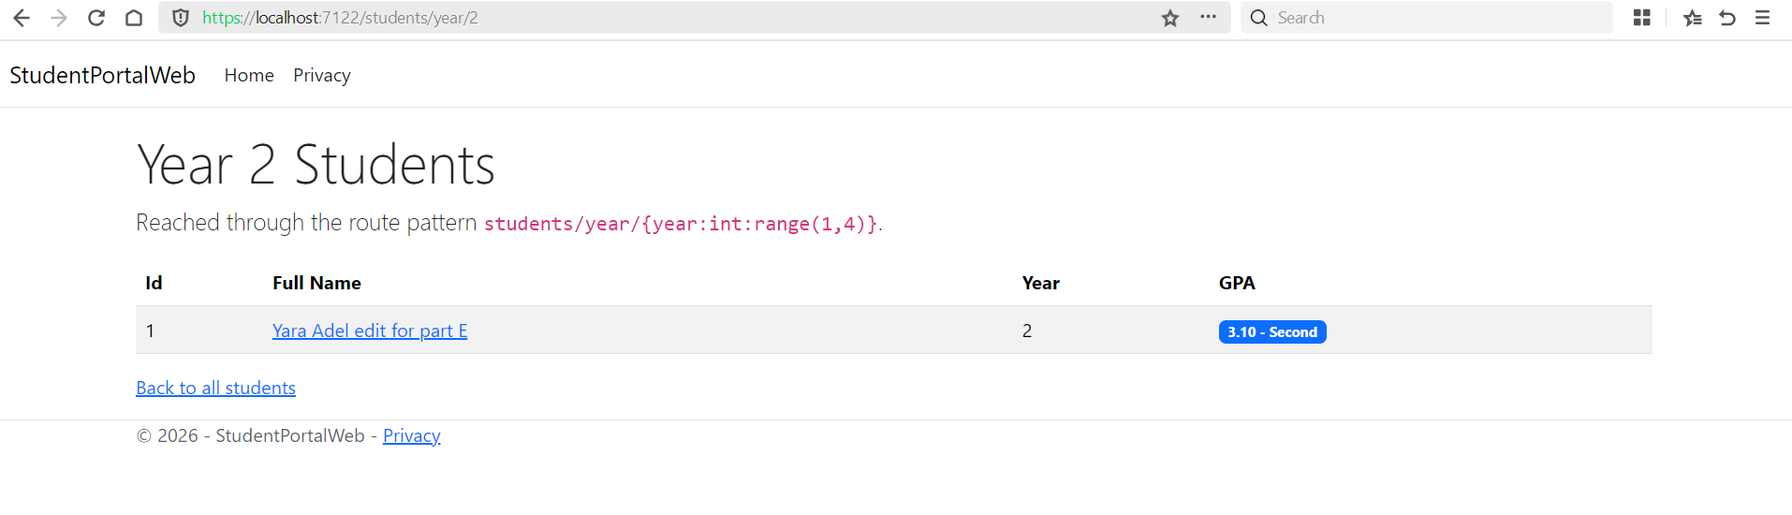
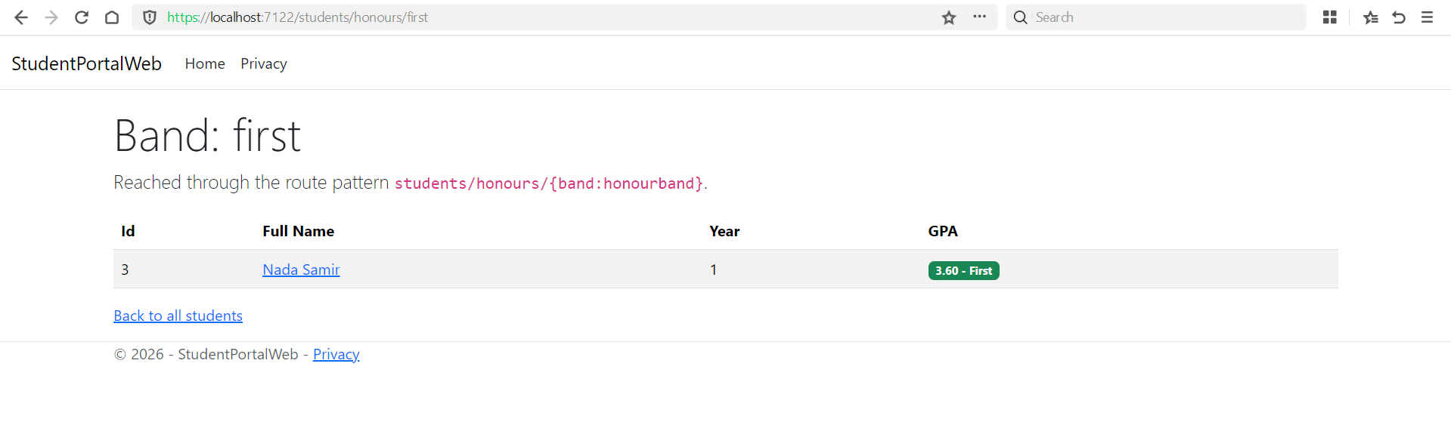
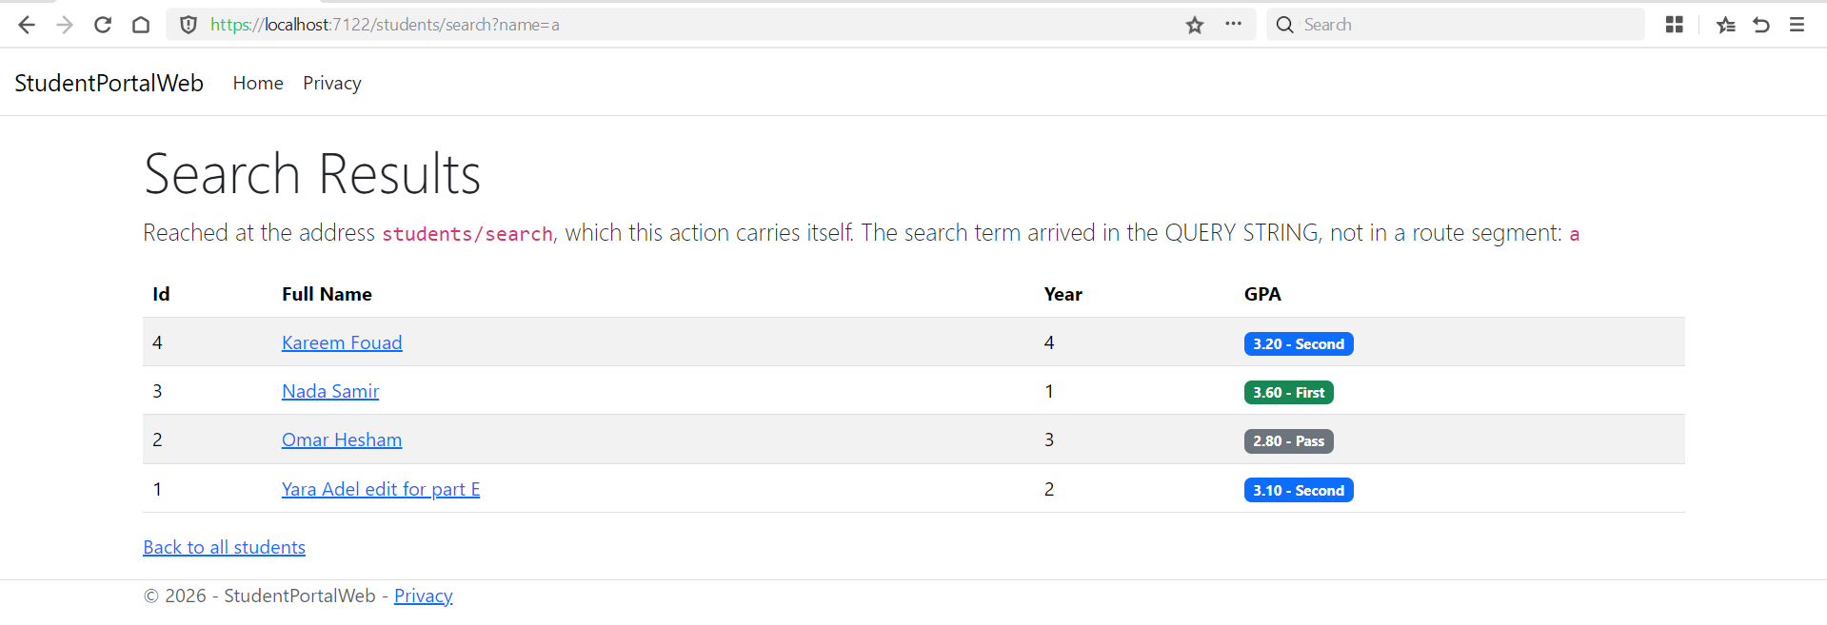

If <partial name="_StudentRow" /> were called here with no model attribute, it would inherit this page's Model — which inside this foreach is the whole List<Student>, not a single Student

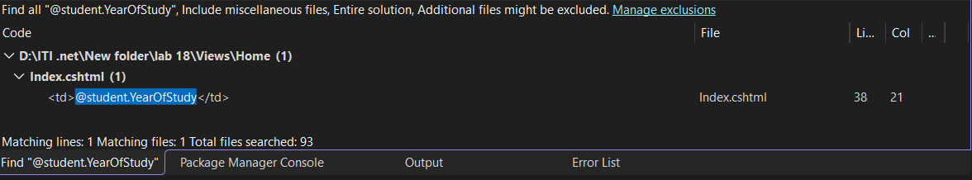

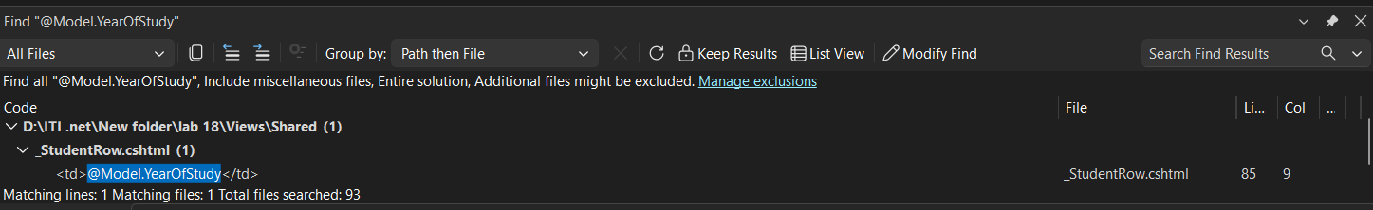

Part C
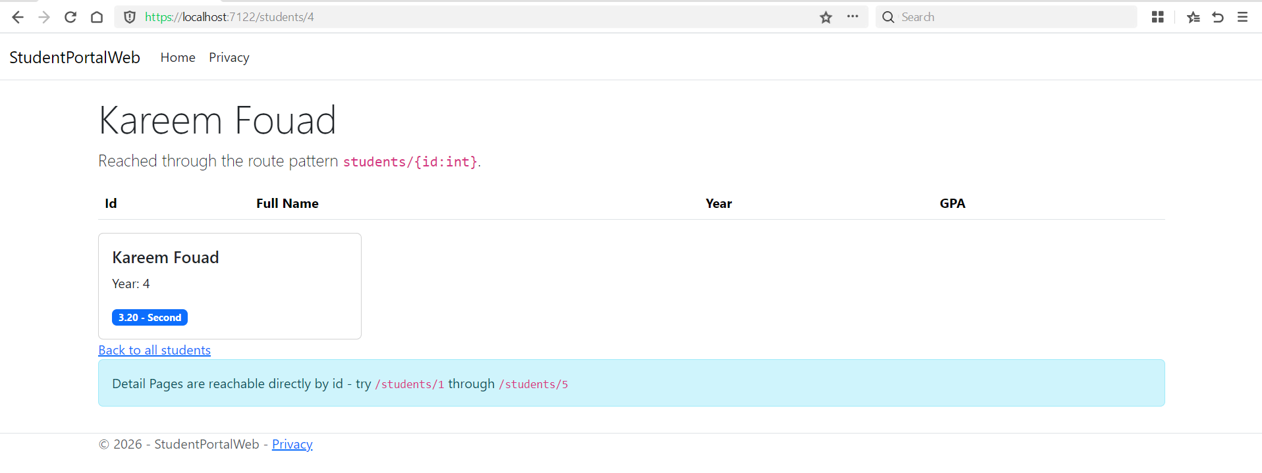
This partial and _StudentRow.cshtml are both handed one Student. A page CAN use both at once each <partial> call passes its own model independently and neither partial knows the other exists

Part D

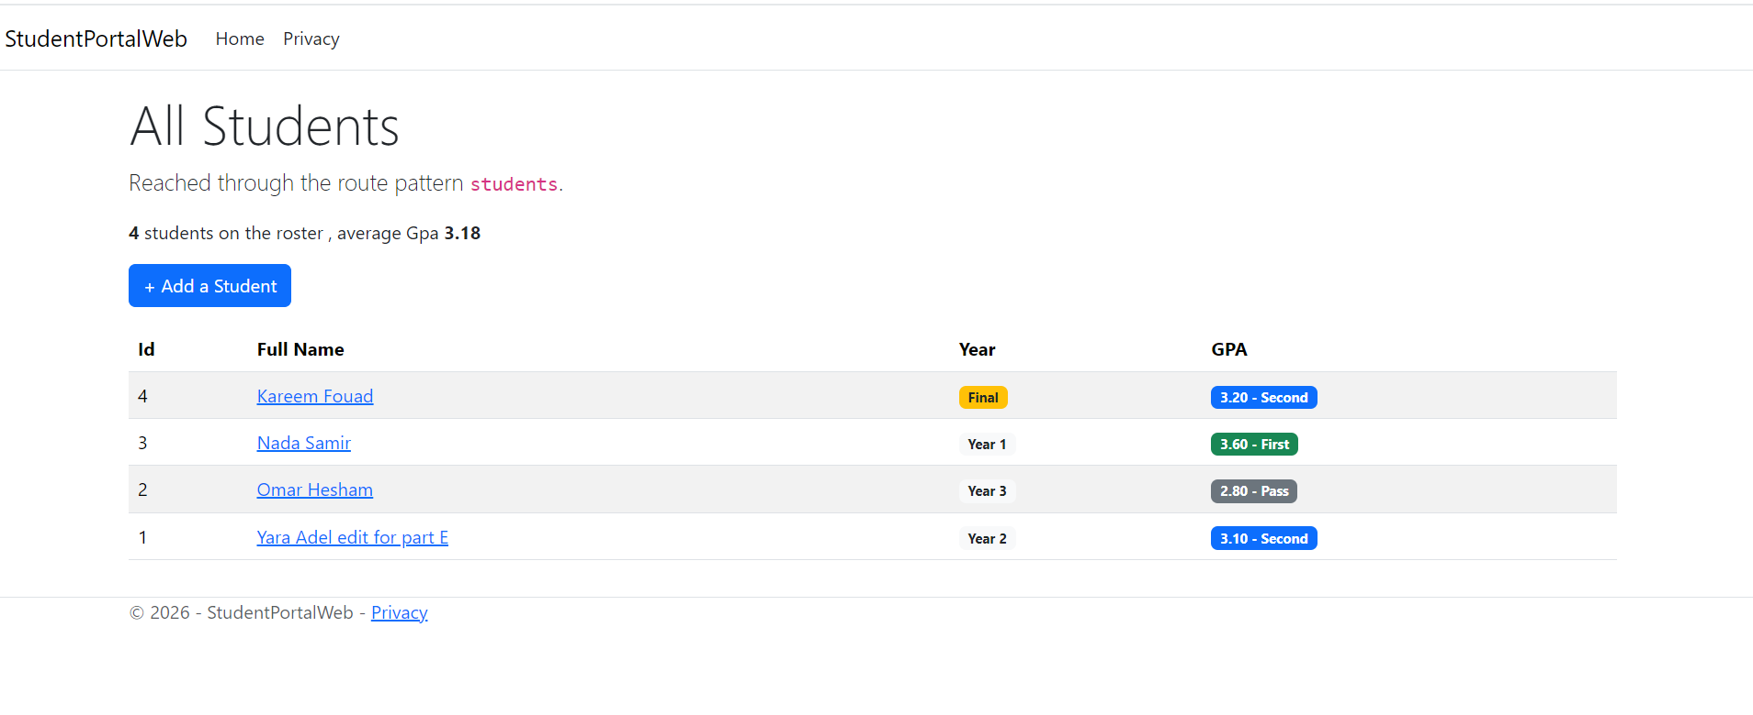

Part E

WHAT THE BROWSER RECEIVED: <td><span class="badge bg-warning text-dark" title="rendered by muhamad Assem">Final</span></td>
Or <td><span class="badge bg-light text-dark" title="rendered by muhamad Assem">Year I (I refer to year)</span></td>

A)removed @addTagHelper *, Lab_18 from _ViewImports: both <gpa-badge> and <year-chip> lose their meaning at once
B) the output defaults to self-closing too — an empty
<span class="badge bg-warning text-dark"> with no visible text

- renamed the element to yearchip (no hyphen) everywhere: Razor no longer recognises it as a custom element at all, so it is passed through as a literal unknown HTML tag
- All three failures are silent

Part F

LAB 18 — Lab ID: 27 | CHIP_YEAR = 4 | CHIP_LABEL = Final

The table of showing the students it was solved using partial view

A route constraint, a validation attribute, and a tag helper are all the same extension shape: inherit a base class or implement an interface defined

`<gpa-badge>` contains a rule — the GPA thresholds that decide who counts as "first" and " Second" and pass `<year-chip>` contains a label it just names whichever year is being highlighted

